**Project 03: Golomb Ruler (100 points, Due Wed Oct 20 before midnight)**

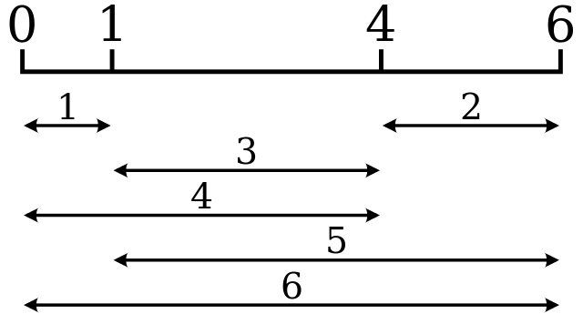

Golomb ruler of order 4 and length 6.  
This ruler is both optimal and perfect.

**Introduction**

A Golomb Ruler of order M and length L consists of M marks placed at unit intervals (i.e. integer positions) along an imaginary ruler such that the differences in spacing between every pair of marks are all distinct, i.e. no two pairs of marks are the same distance apart. The number of marks on the ruler is its order, and the largest distance between two of its marks is its length.

For example the four marks placed at 0, 1, 4 and 6 constitutes a Golomb ruler of order 4 and length 6.

Implement a CSP solution to verify whether or not a Golomb ruler of a fixed length L for M marks exists.

If a solution exists for length L find an optimal length ruler, that is one for which no shorter length ruler exists for M marks.

Generate statistics on the number of consistency checks performed for CSP solution with:

1. Plain Backtracking (BT) [45 points]
2. BT + Forward Checking (FC) [45 points]
3. (BONUS) BT + Constraint Propagation (CP) [20 points]

**What to Submit:** You should submit a zip file containing:

* Source code [submit.py](http://www3.cs.stonybrook.edu/~cse537/project03/submit.py) (Python 2.x) with good documentation
* Test set
* A report with the required statistics generated for each problem

The name of the functions you have to implement and the format of your input/output is described in [submit.py](http://www3.cs.stonybrook.edu/~cse537/project03/submit.py). All the project submissions must be made through Blackboard.

**Report (5 points)**The report should have the analysis/statistics generated for each problem.

**Documentation (5 points)**Your code will be reviewed for comments and good documentation.

**Academic Dishonesty:** We will be checking your code against other submissions in the class for logical redundancy. If you copy someone else's code and submit it with minor changes, we will know. These cheat detectors are quite hard to fool, so please don't try. We trust you all to submit your own work only; *please* don't let us down. If you do, we will pursue the strongest consequences available to us.

**Getting Help:** Feel free to use the Piazza discussion board to discuss or get clarifications on homework-related issues. If you find yourself stuck on something, go to office hours or email the TAs for help. We want these projects to be rewarding and instructional, not frustrating and demoralizing. But, we don't know when or how to help unless you ask.